Web Project

Literary Interpretation

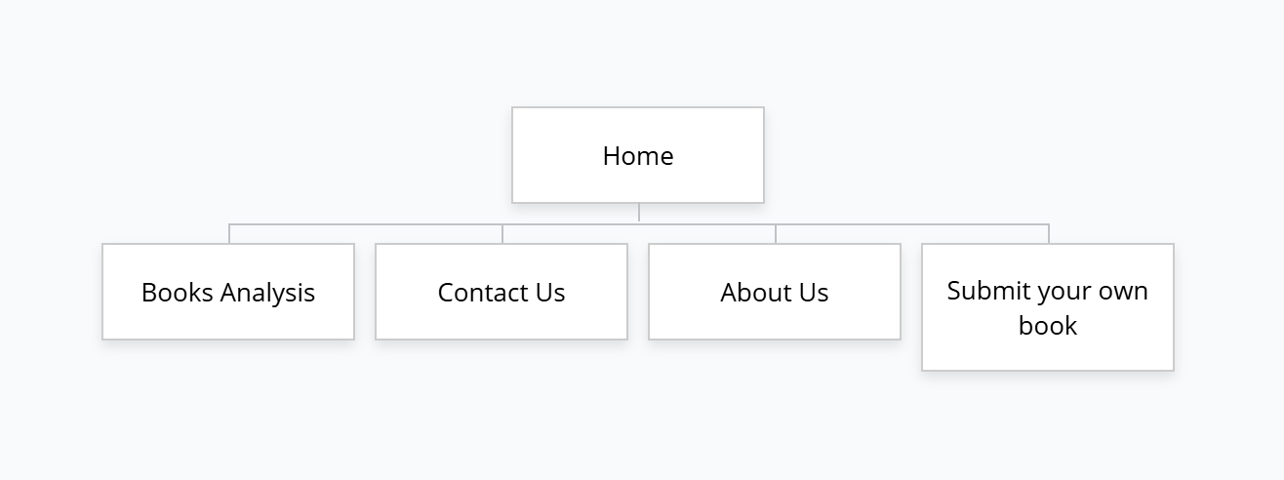This is the site map of my project of Literary Interpretation.

References:

*Unsplash (no date) 550+ books pictures: Download free images on unsplash, 550+ Books Pictures | Download Free Images on Unsplash. Available at: https://unsplash.com/s/photos/books (Accessed: 09 December 2024)*.

Created By:Ishan Poudel Submitted to: Dipendra Silwal